**Task 1**

# **Steps to complete your Git-hub and its Git Repository**

**Step 1:-** Register your self on Git-hub by entering your Email.

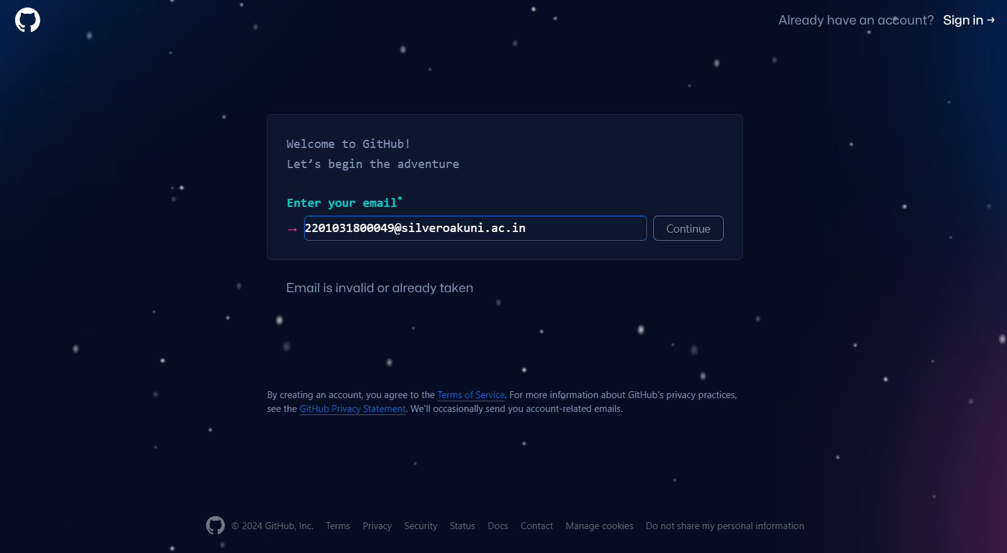

**Step 2:-** Enter your Password.

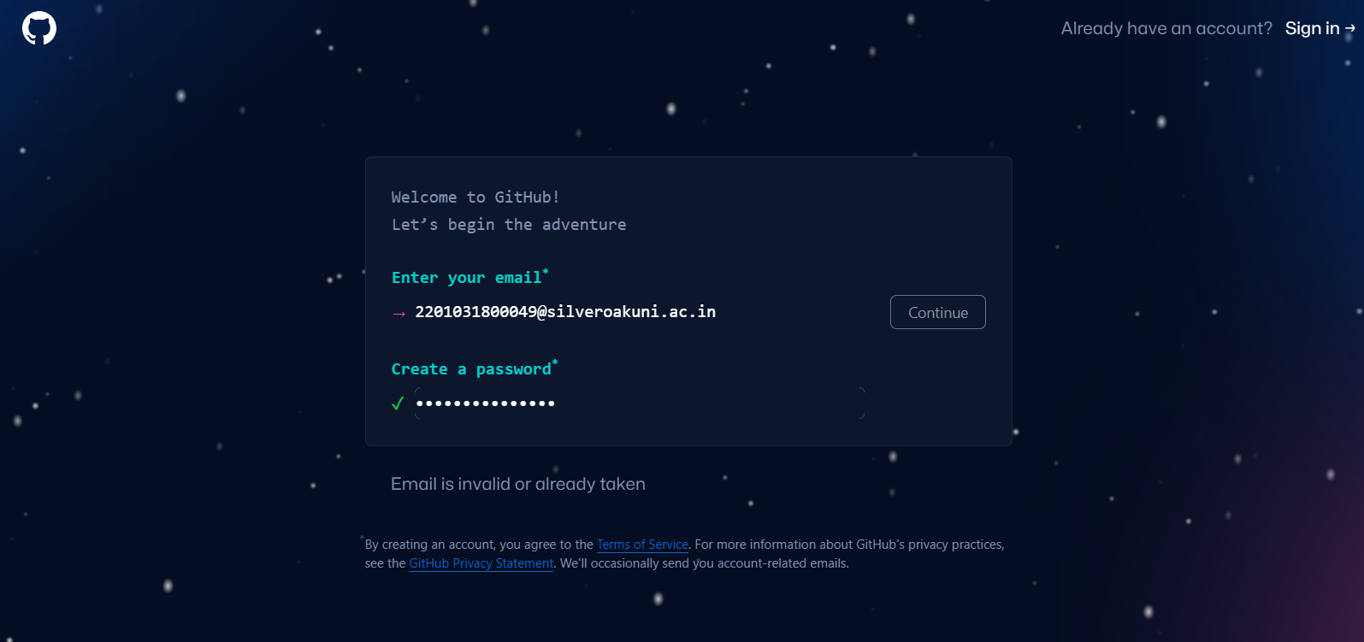

**Step 3:-** Choose unique username for your account.

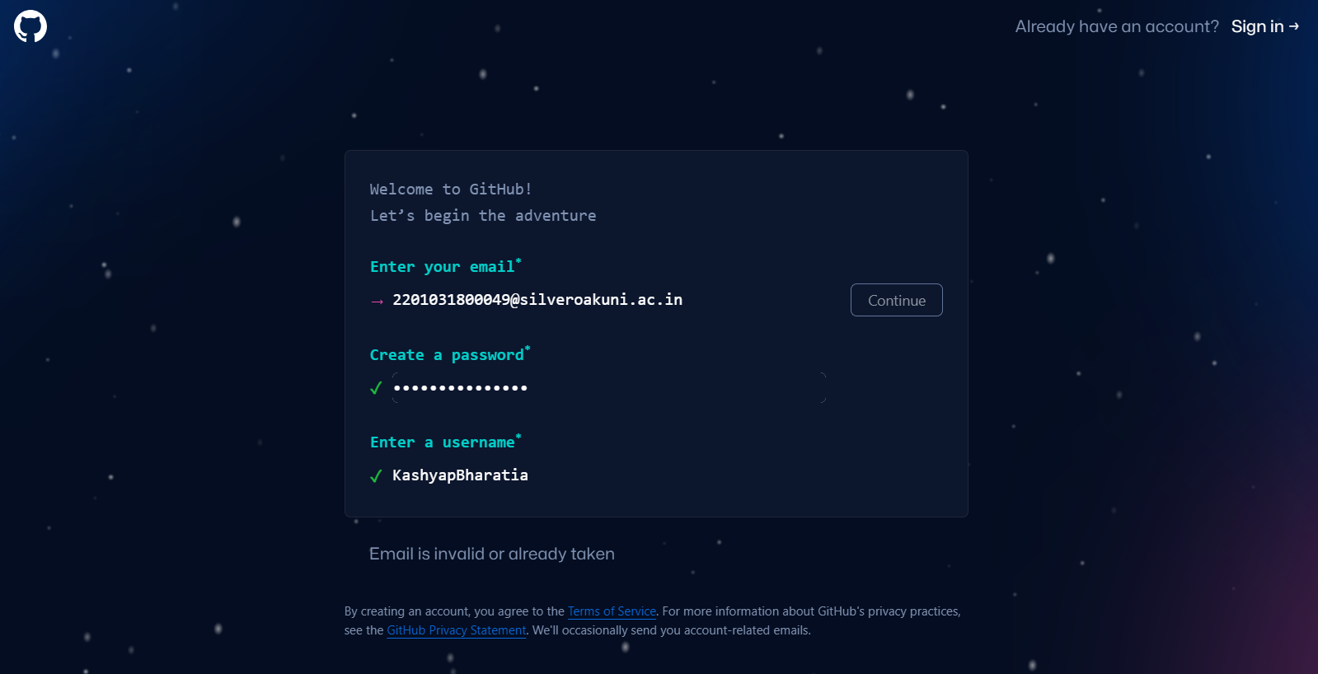

**Step 4:-** Verify your self and then click on Create Account.

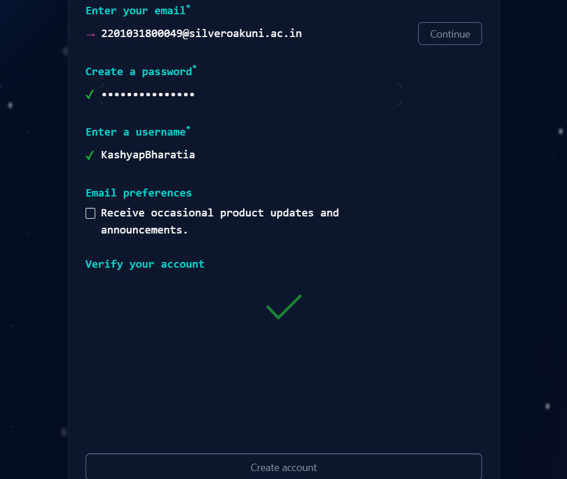

**Step 5:-** So, Your account was created successfully. Now complete your account personalization.

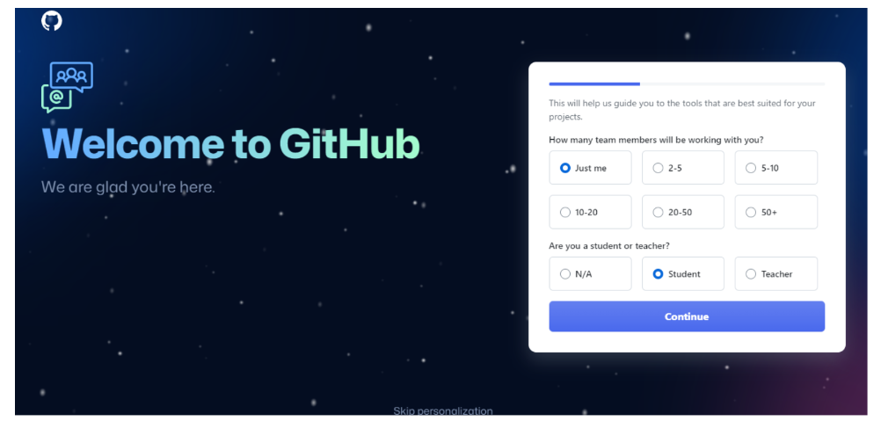

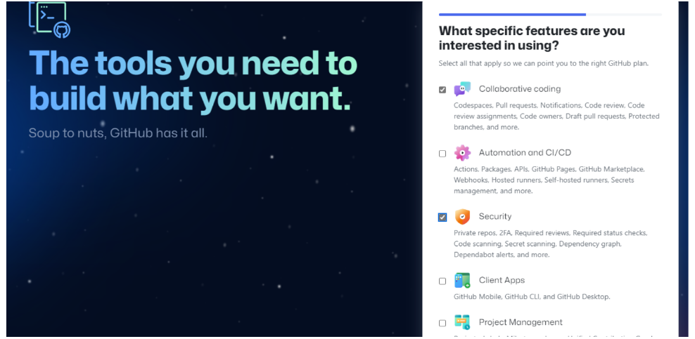

**Step 6:-** Ater creating your account and completing personalization click on create new repository.

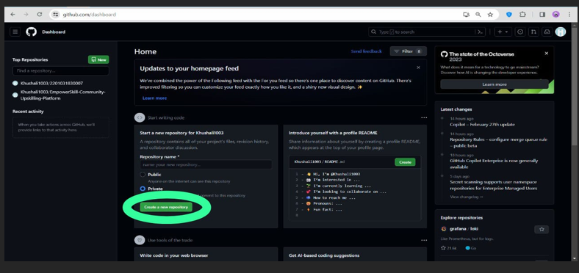

**Step 7:-** Name your Repository as your Enrollment number.

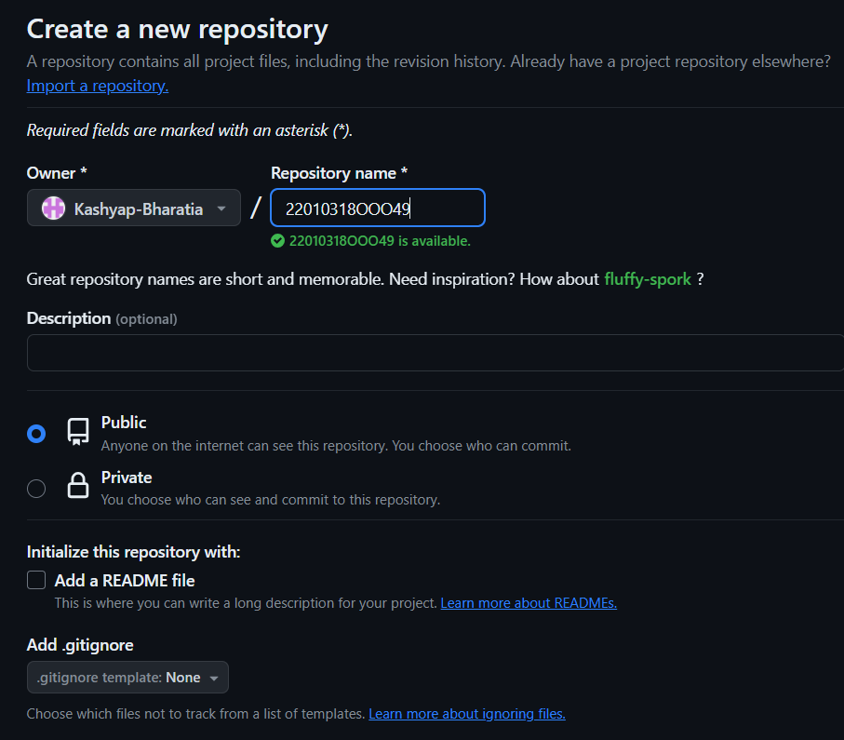

**Step 8:-** Now click on ‘Add file’ option to create a folder in the repository. We are required to create 2 folders here in our repository, named as ‘Assignment_1’ and ‘Assignment_2’.

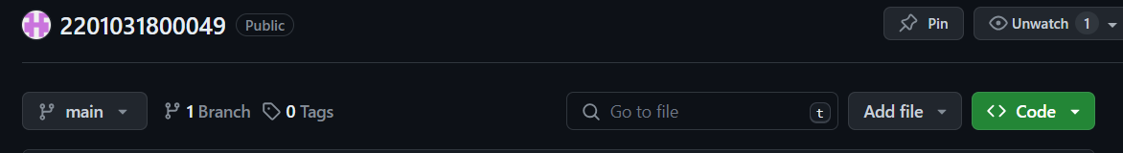

**Step 9:-** Write your folder name in the specified area(Assignment_1 and Assignment_2).

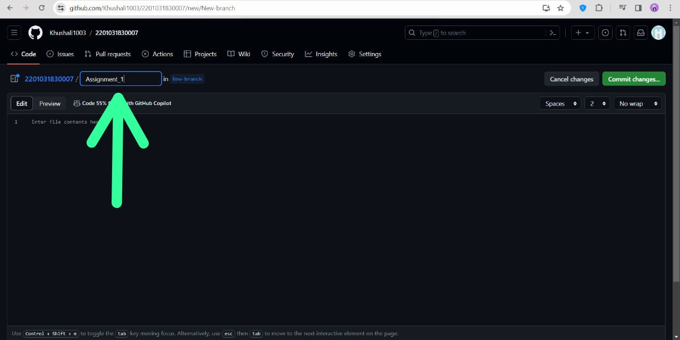

**Step 10:-** Now move forward by clicking on Commit Changes option.

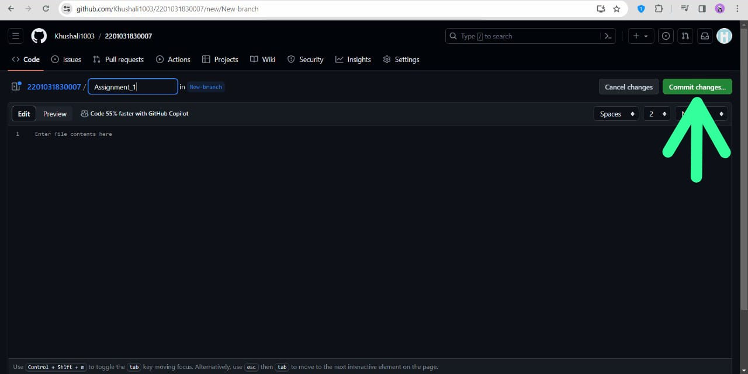

**Step 11:-** Same way like this create folder named Assignment_2

**Step 12:-** Now you’ll be able to see two folders that you created in your repository.

